TOPIC 3-DIVIDE & CONQUER
1.
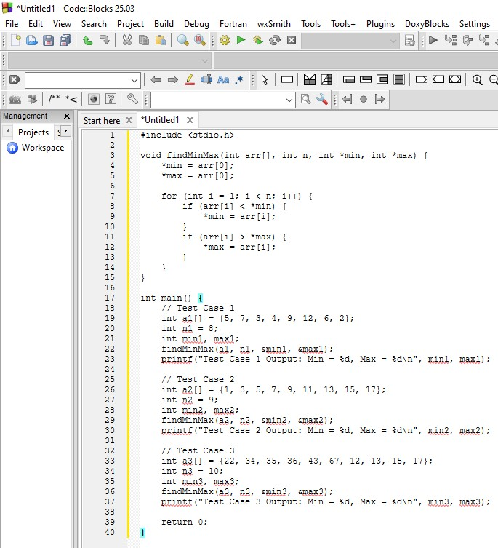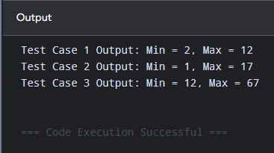
Time complexity: $O\left(N\right)$
Space Complexity: $O\left(1\right)$

2.
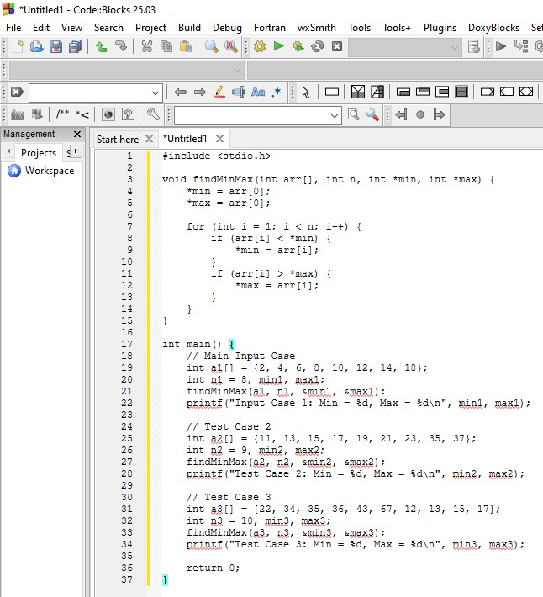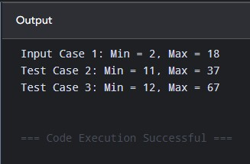
Time complexity: $O\left(N\right)$
Space complexity: $O\left(1\right)$

3.
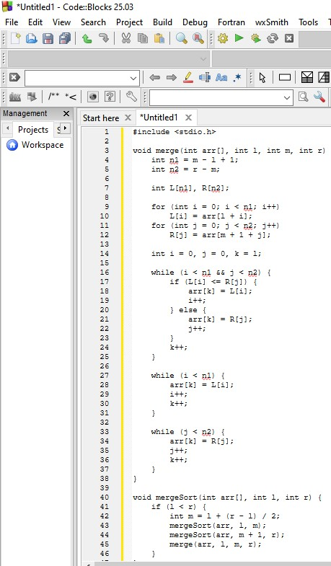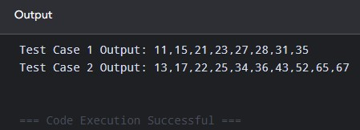
Time Complexity: O(N log N)
Space Complexity: O(N)

4.
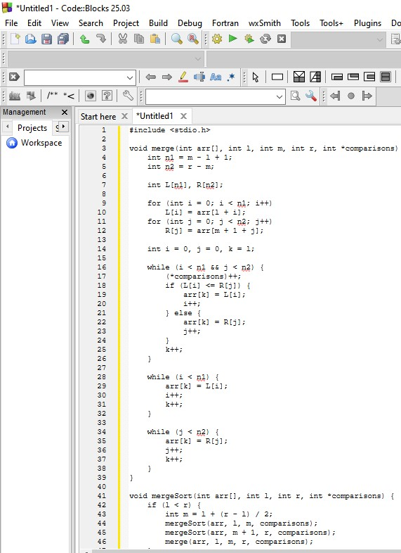
Output:
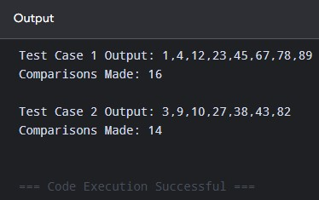
Time Complexity: O(N log N)
Space Complexity: O(N)

5.
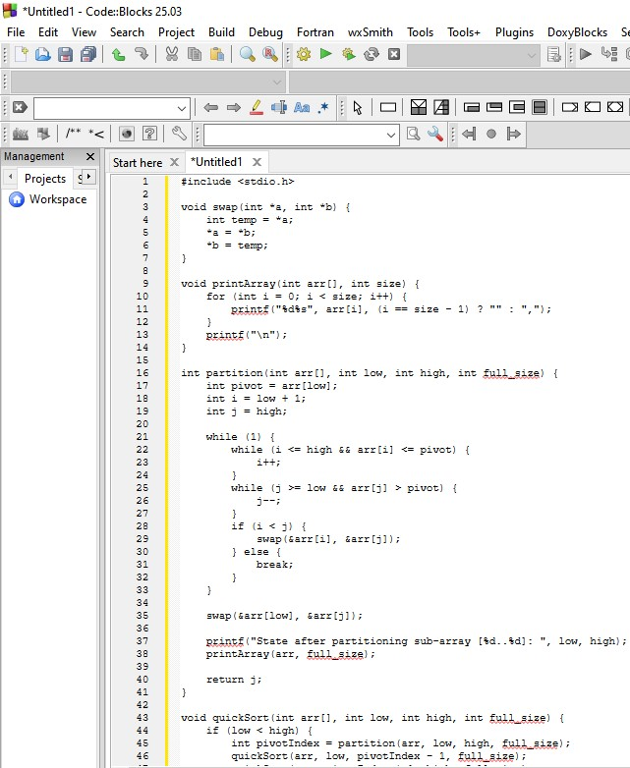
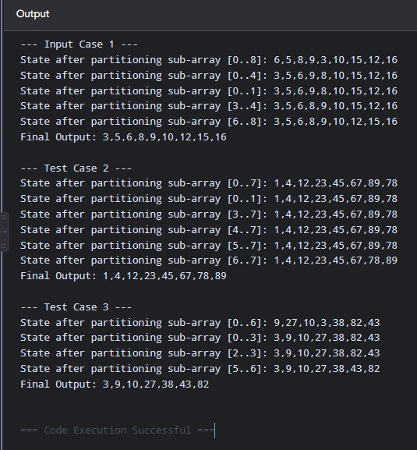
Output:

Time Complexity: O(N log N) average / O(N^2) worst case
Space Complexity: O(log N) average / O(N) worst case

6
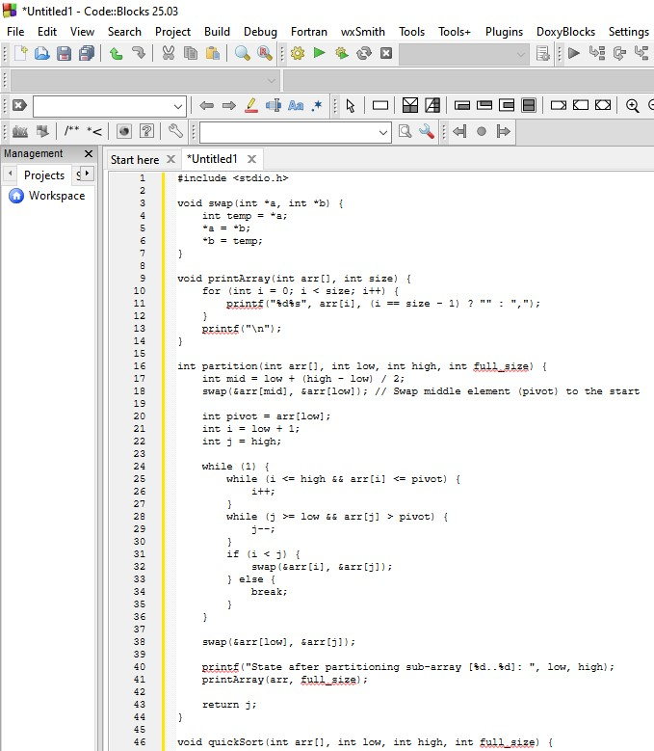
Output:
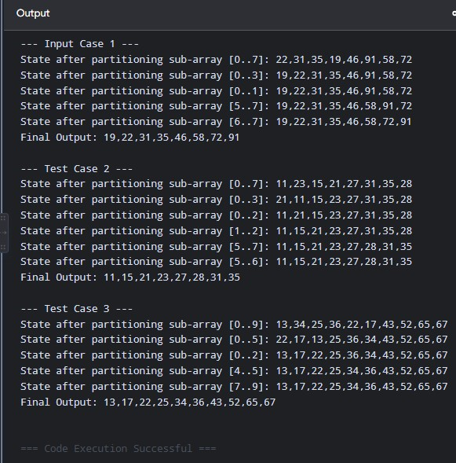
Time Complexity: O(N log N) average / O(N^2) worst case
Space Complexity: O(log N) average / O(N) worst case

7.
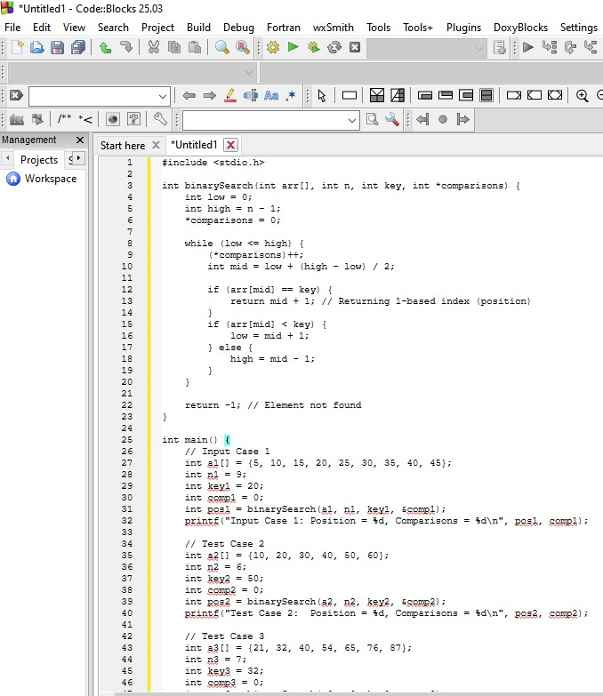
Output:
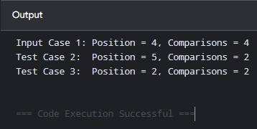
Time Complexity: O(log N)
Space Complexity: O(1)

8.
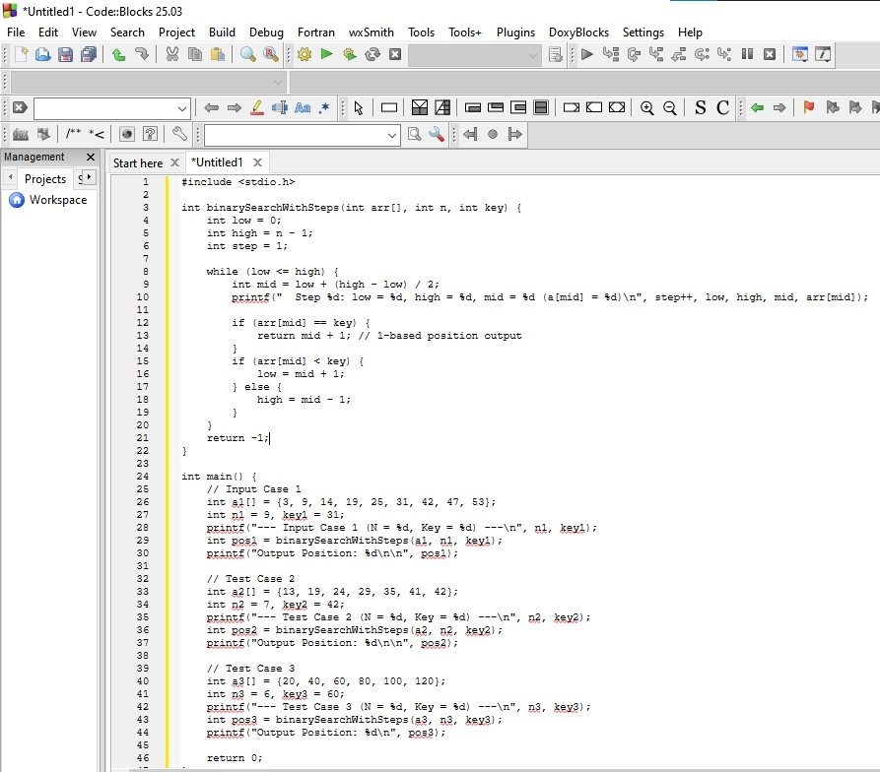
Output:
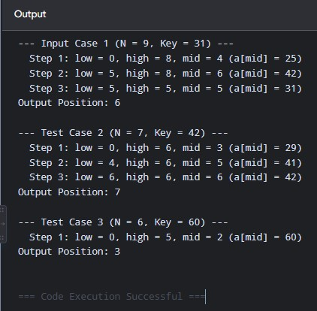
Time Complexity: O(log N)
Space Complexity: O(1)

9.
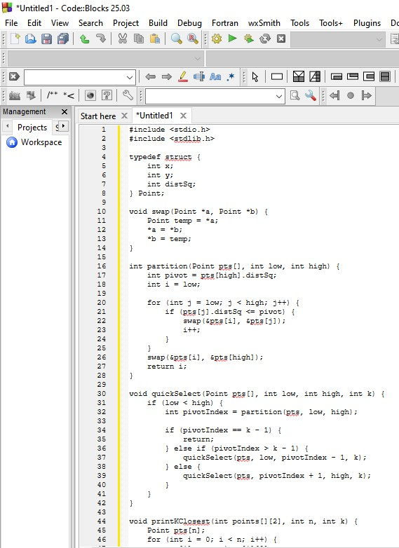
Output:
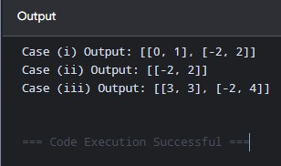
Time Complexity: O(N) average / O(N^2) worst case
Space Complexity: O(N) auxiliary space

10.
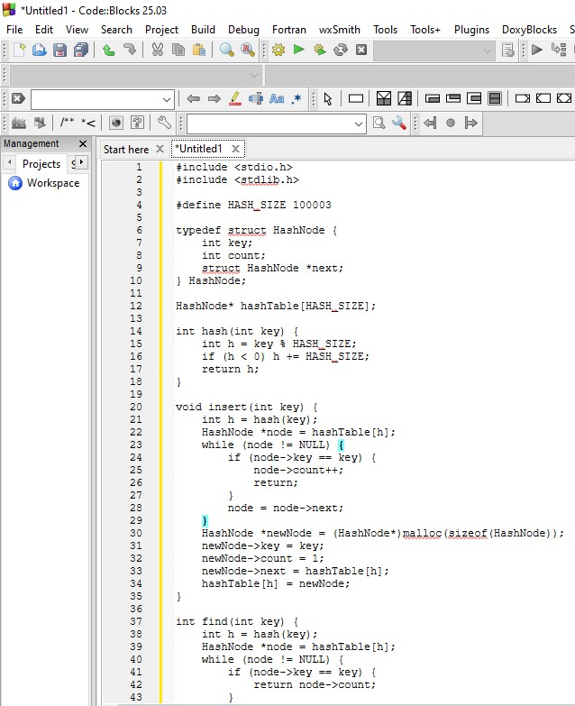
Output:
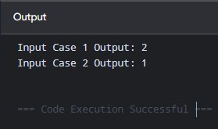
Time Complexity: O(N^2)
Space Complexity: O(N^2)

11.
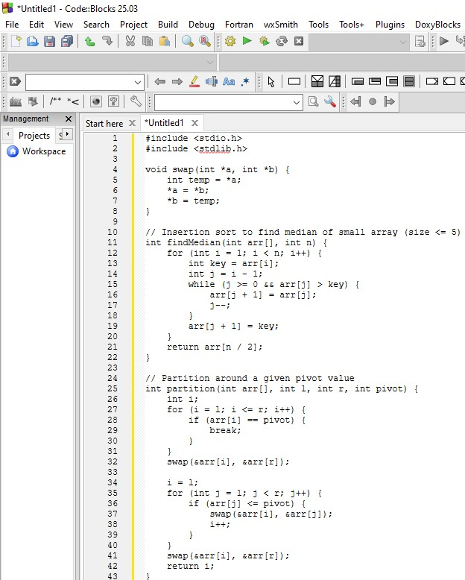
Output:
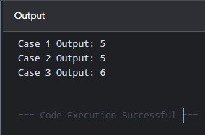
Time Complexity: O(N) worst-case
Space Complexity: O(log N) due to recursive call stack

12.
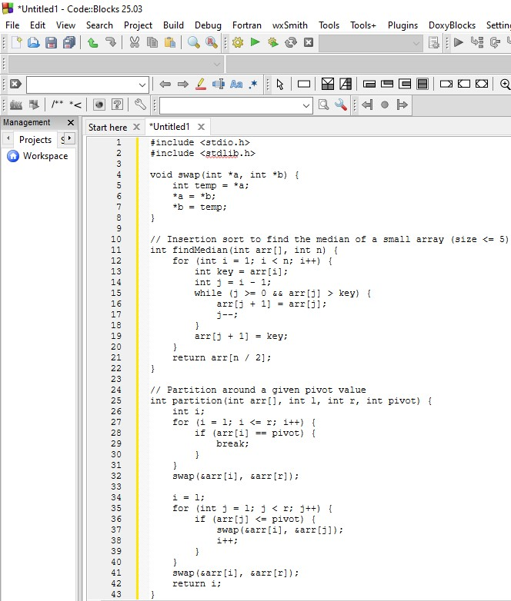
Output:
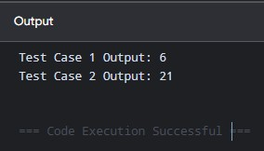
Time Complexity: O(N) worst-case
Space Complexity: O(log N) due to recursive call stack

13.
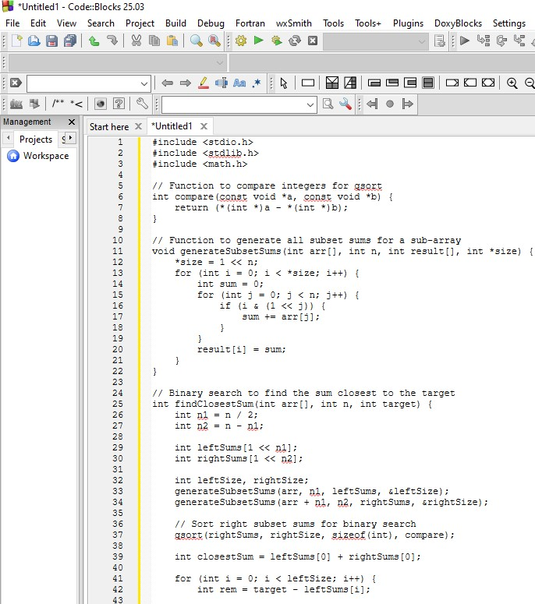
Output:
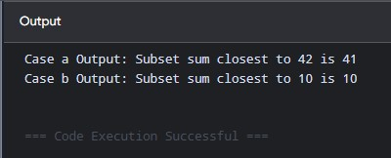
Time Complexity: O(2^(N/2) * N)
Space Complexity: O(2^(N/2))

14.
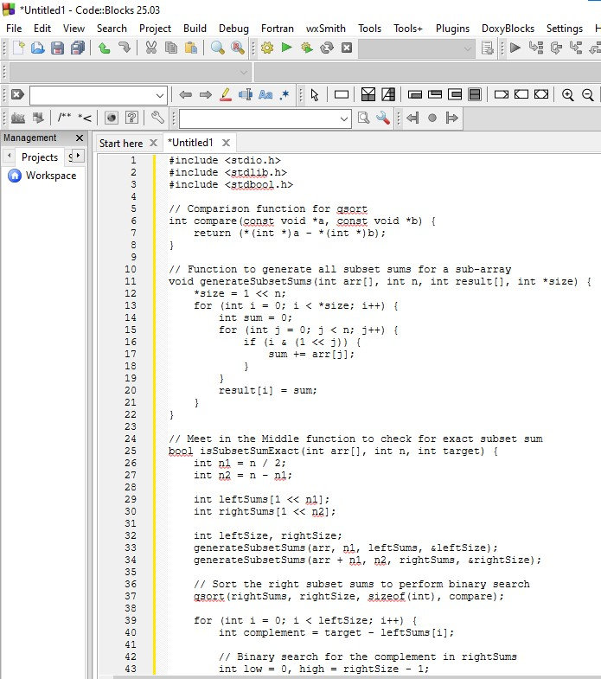
Output:
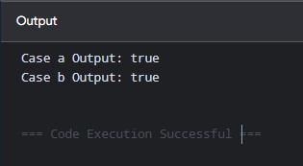
Time Complexity: O(2^(N/2) * N)
Space Complexity: O(2^(N/2))

15.
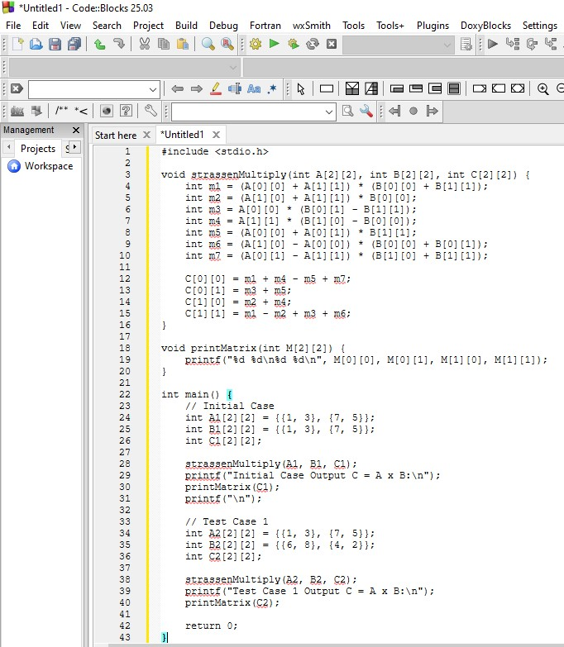
Output:
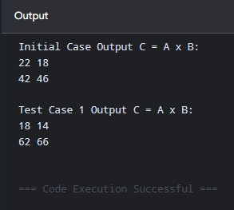
Time Complexity: O(N^{log_2 7}) ≈ O(N^{2.81}) [O(1) for a fixed 2x2 matrix]
Space Complexity: O(1)

16.
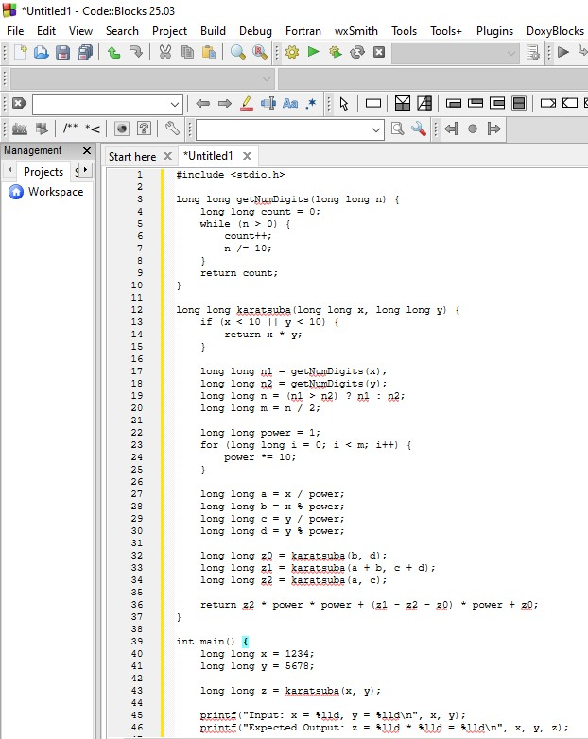
Output:
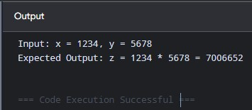
Time Complexity: O(N^{log_2 3}) ≈ O(N^{1.585})
Space Complexity: O(log N) due to recursive call stack

